WEEK 2- Learning to use AI well
I uploaded the data of a laundry service for the year 2024. This data covered all 10 outlets they have as well as 8 months in the year(January,Febuary,July,August,September,October,November,December).
These are the four prompts used to improve the results which will be generated by the Ai(Grok)
- PROMPT 1
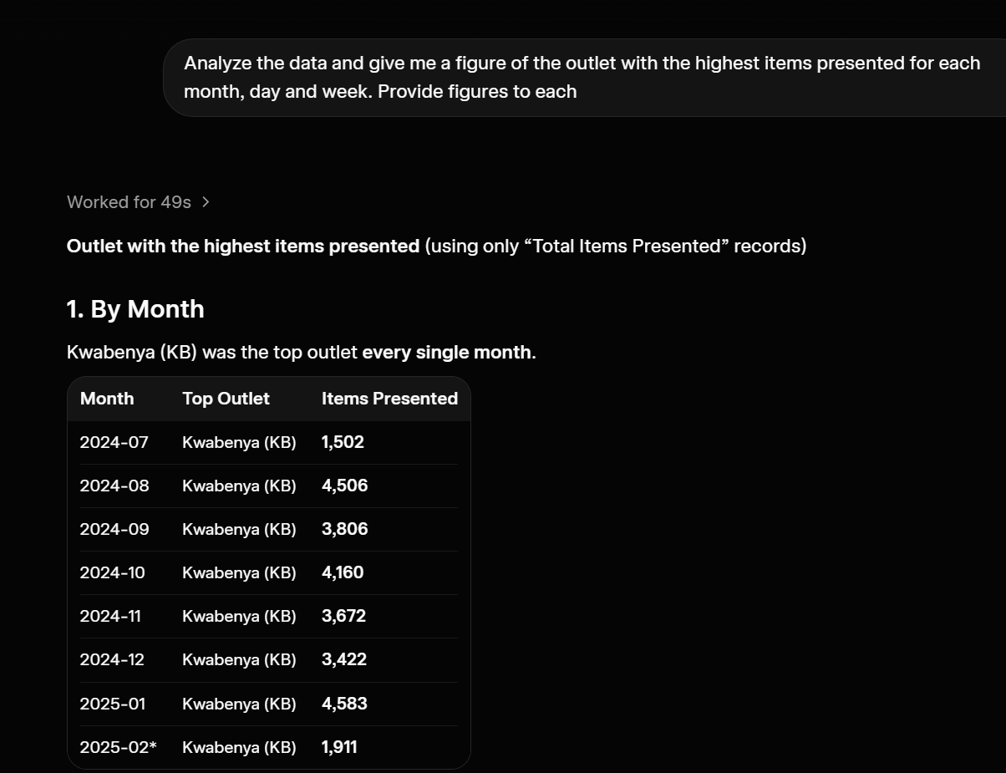
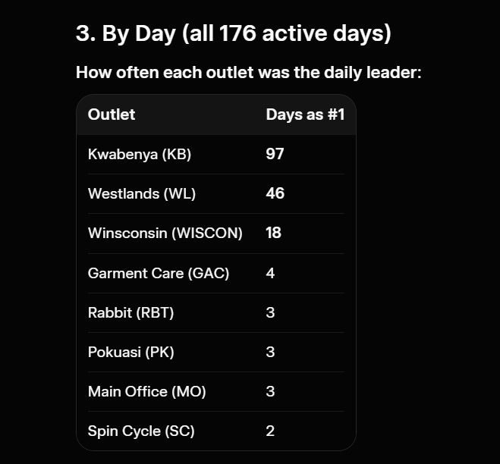
2. BY WEEK  Week | Top Outlet | Items Presented
2024-W28 | Winsconsin (WISCON) | 108
2024-W30 | Kwabenya (KB) | 894
2024-W31 | Kwabenya (KB) | 1,268
2024-W32 | Kwabenya (KB) | 1,178
2024-W33 | Kwabenya (KB) | 915
2024-W34 | Kwabenya (KB) | 906
2024-W35 | Kwabenya (KB) | 772
2024-W36 | Kwabenya (KB) | 1,079
2024-W37 | Kwabenya (KB) | 933
2024-W38 | Kwabenya (KB) | 902
2024-W39 | Westlands (WL) | 794
2024-W40 | Kwabenya (KB) | 921
2024-W41 | Kwabenya (KB) | 927
2024-W42 | Kwabenya (KB) | 909
2024-W43 | Kwabenya (KB) | 1,054
2024-W44 | Kwabenya (KB) | 858
2024-W45 | Kwabenya (KB) | 807
2024-W46 | Kwabenya (KB) | 947
2024-W47 | Kwabenya (KB) | 774
2024-W48 | Kwabenya (KB) | 782
2024-W49 | Westlands (WL) | 712
2024-W50 | Kwabenya (KB) | 988
2024-W51 | Kwabenya (KB) | 1,190
2024-W52 | Westlands (WL) | 331
2025-W01 | Westlands (WL) | 830
2025-W02 | Kwabenya (KB) | 1,549
2025-W03 | Westlands (WL) | 870
2025-W04 | Westlands (WL) | 766
2025-W05 | Kwabenya (KB) | 1,249
2025-W06 | Kwabenya (KB) | 959
2025-W07 | Kwabenya (KB) | 789
Key Takeaways
- Kwabenya (KB) is by far the dominant outlet. It led every month, most weeks, and 97 out of 176 days.
- Westlands (WL) came in second, frequently taking the daily lead (especially in late 2024 / early 2025).
- Highest single-day figure for any outlet: Kwabenya on 19 Dec 2024 with 466 items.
- Highest single-week figure: Kwabenya in 2025-W02 with 1,549 items.
What the changed improved

- PROMPT 2
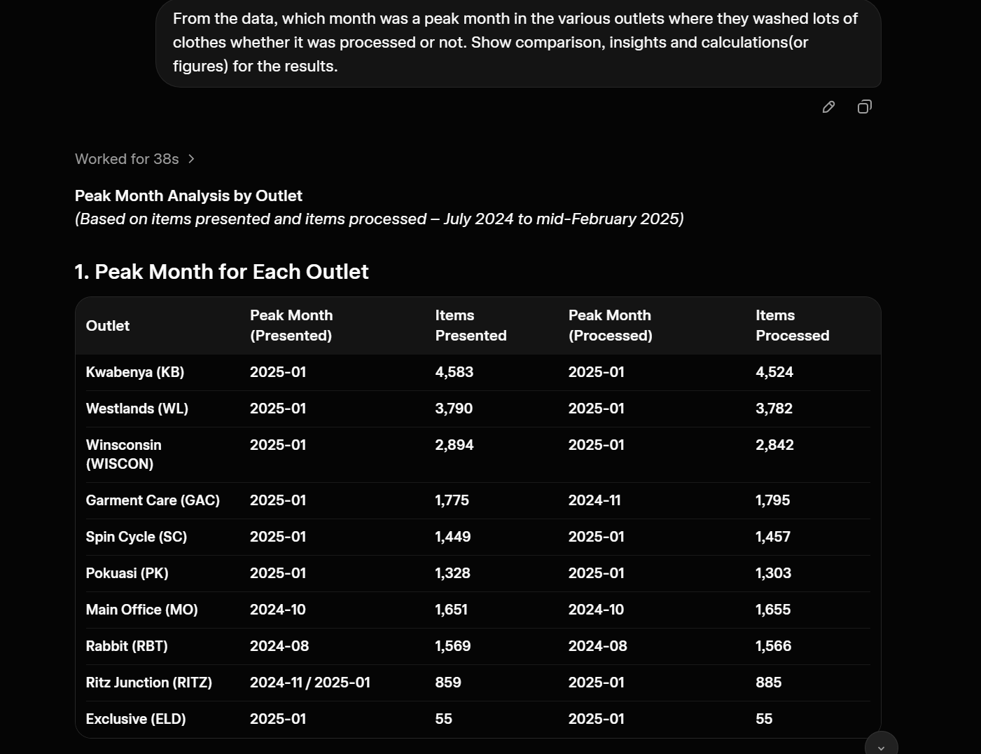
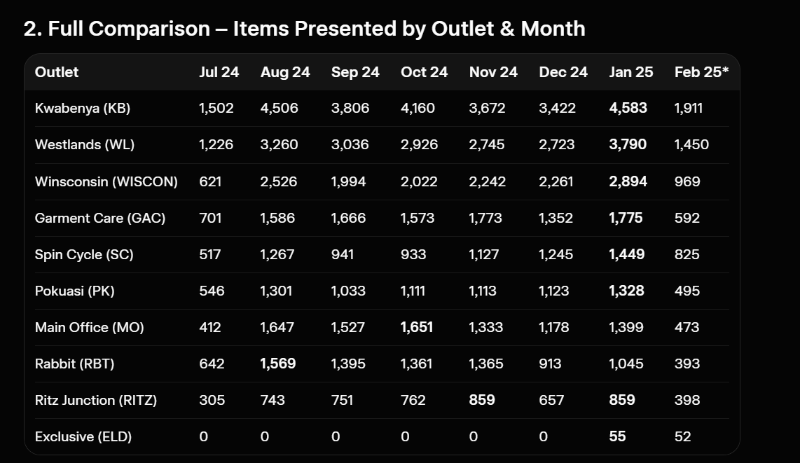
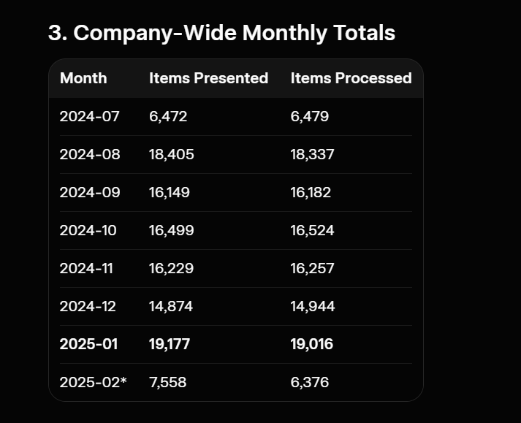
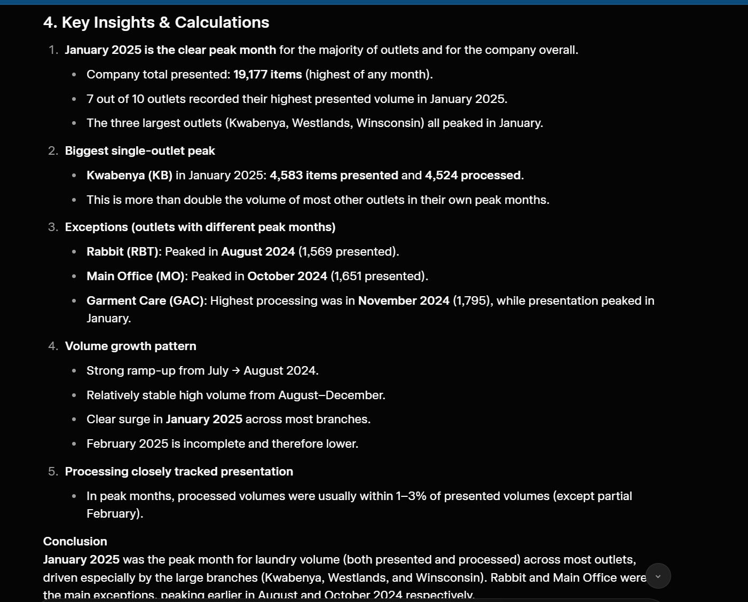
- PROMPT 3
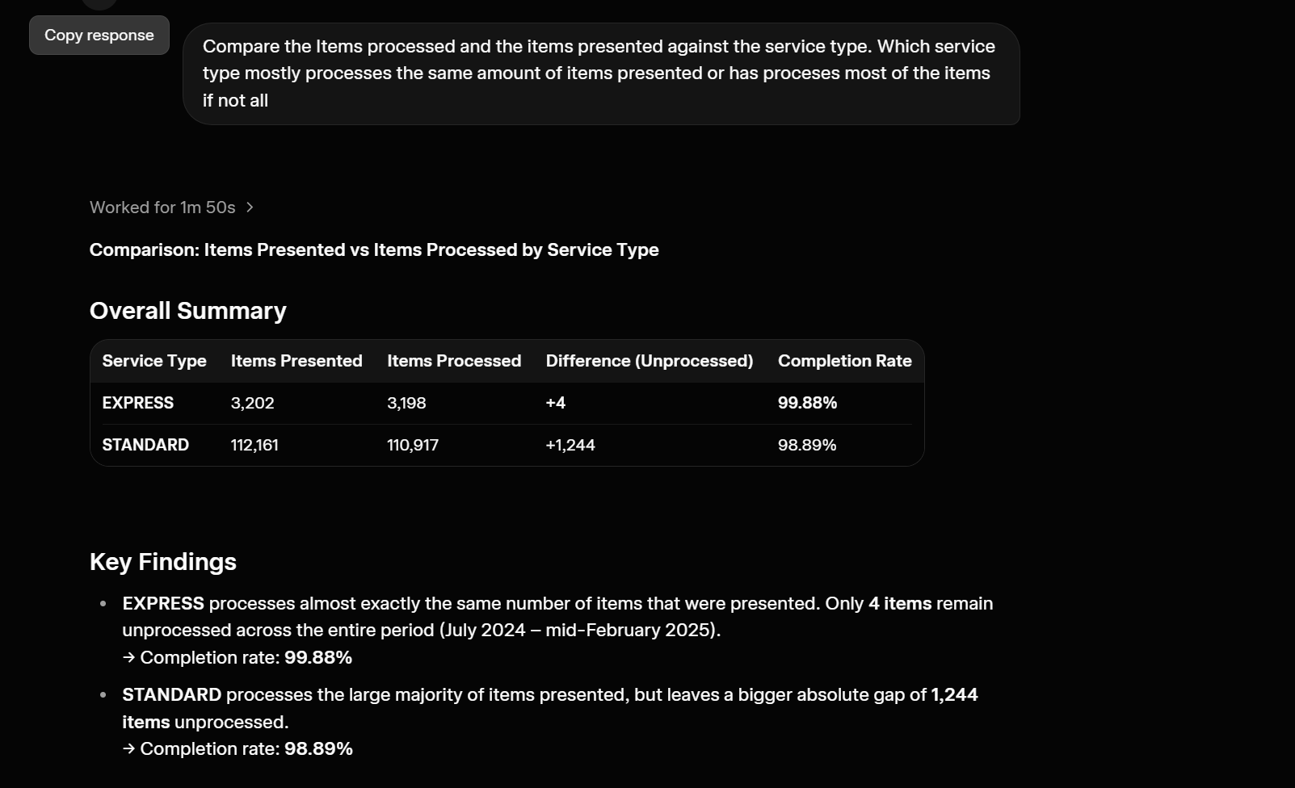
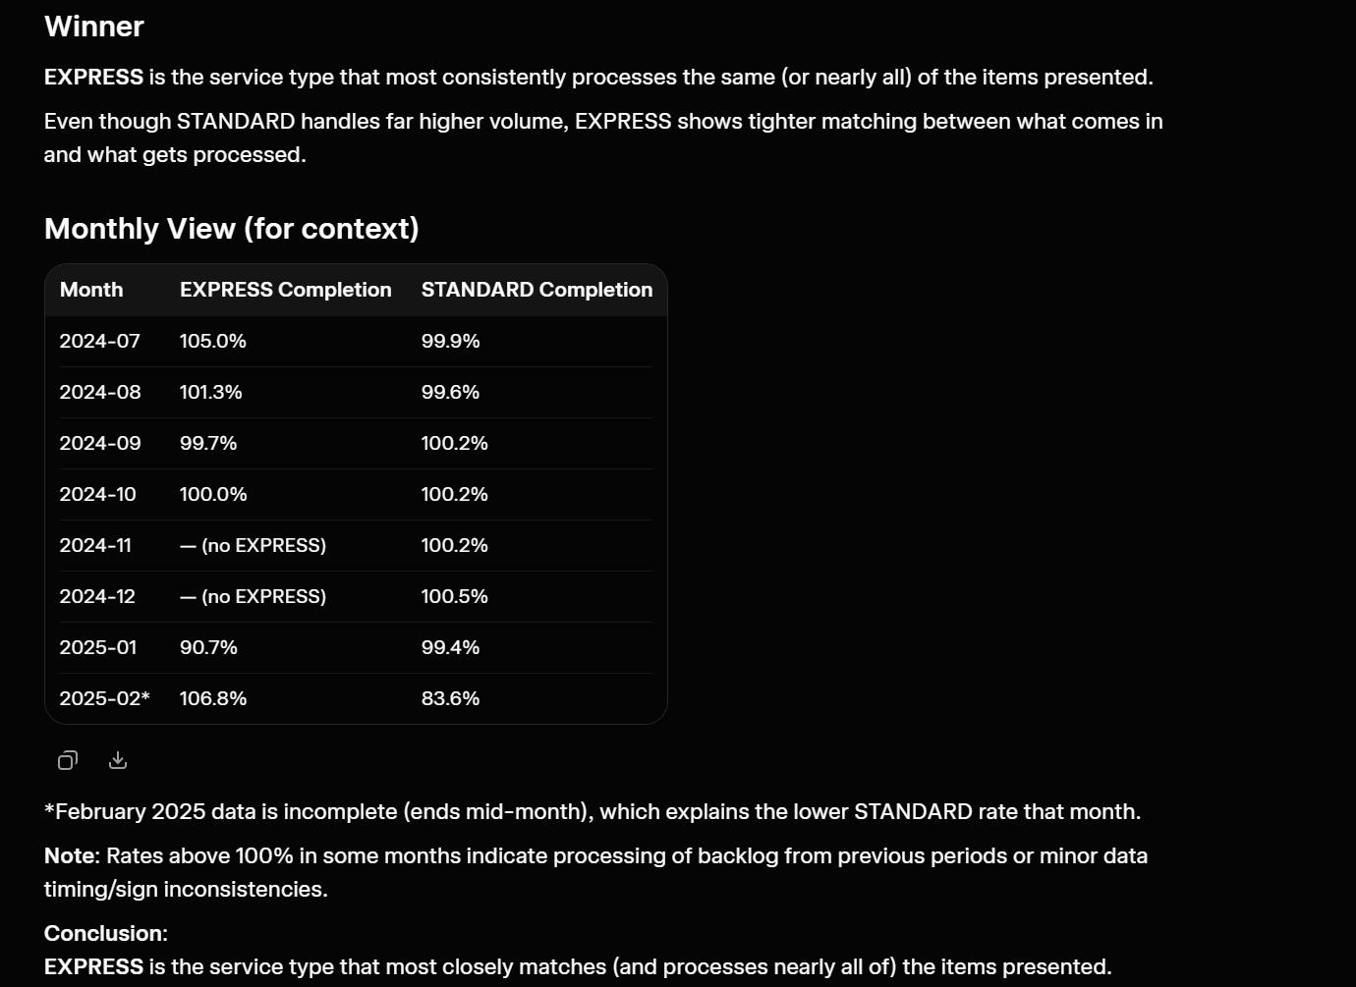

- PROMPT 4
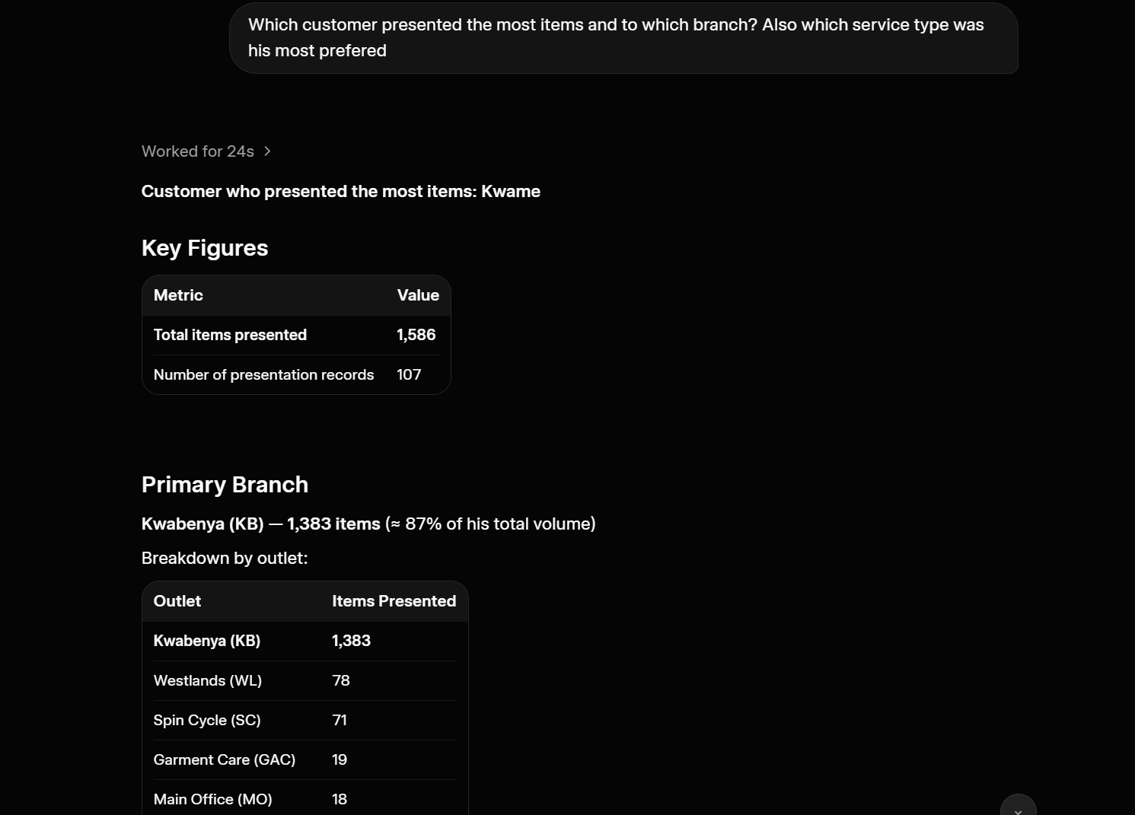

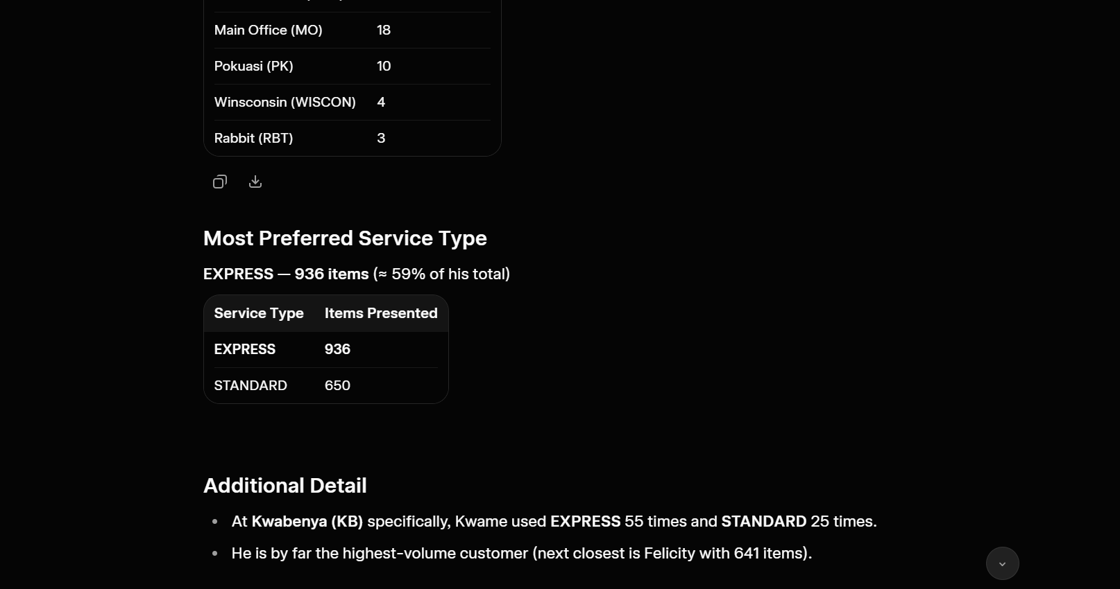

WHAT IMPROVED AFTER USING THE FOUR PROMPTS
- The improvements make the analysis focused. The AI now knows that the main objective is to identify the highest-volume customer, their outlet, and their preferred service type
- Adding the improvements tells the AI exactly how the answer should be presented
- The prompt improved by adding the goal, context, example, and output format. Adding it made the instructions clearer and helped produce a more focused, accurate, and useful analysis
- This makes the analysis more accurate and reduces the chance of interpreting the data incorrectly.

